Section 1: Introduction to Linux
- Open Source Operating System that is widely used and provide following features
  - Reliable
  - Free of Cost (Open-Source)
  - Software Management
  - Security
  - Performance
  - Freedom
  - Customization

Section 3: Understand & Use of Essential Tools

Terminal
The terminal allows the user to perform different system operations using the command line interface. The terminal follows this format: username@machine_name Directory $/#. ~ marks the home directory of logged in users. $ marks non-root user and # marks the root user
$ date -> displays current date & time
$ man command -> manual page of a command listing format and acceptable parameters
$ uptime -> shows uptime of the system along with logged in user
$ who -> display the details of logged in users
$ pwd -> shows current working directory

Linux File System Hierarchy
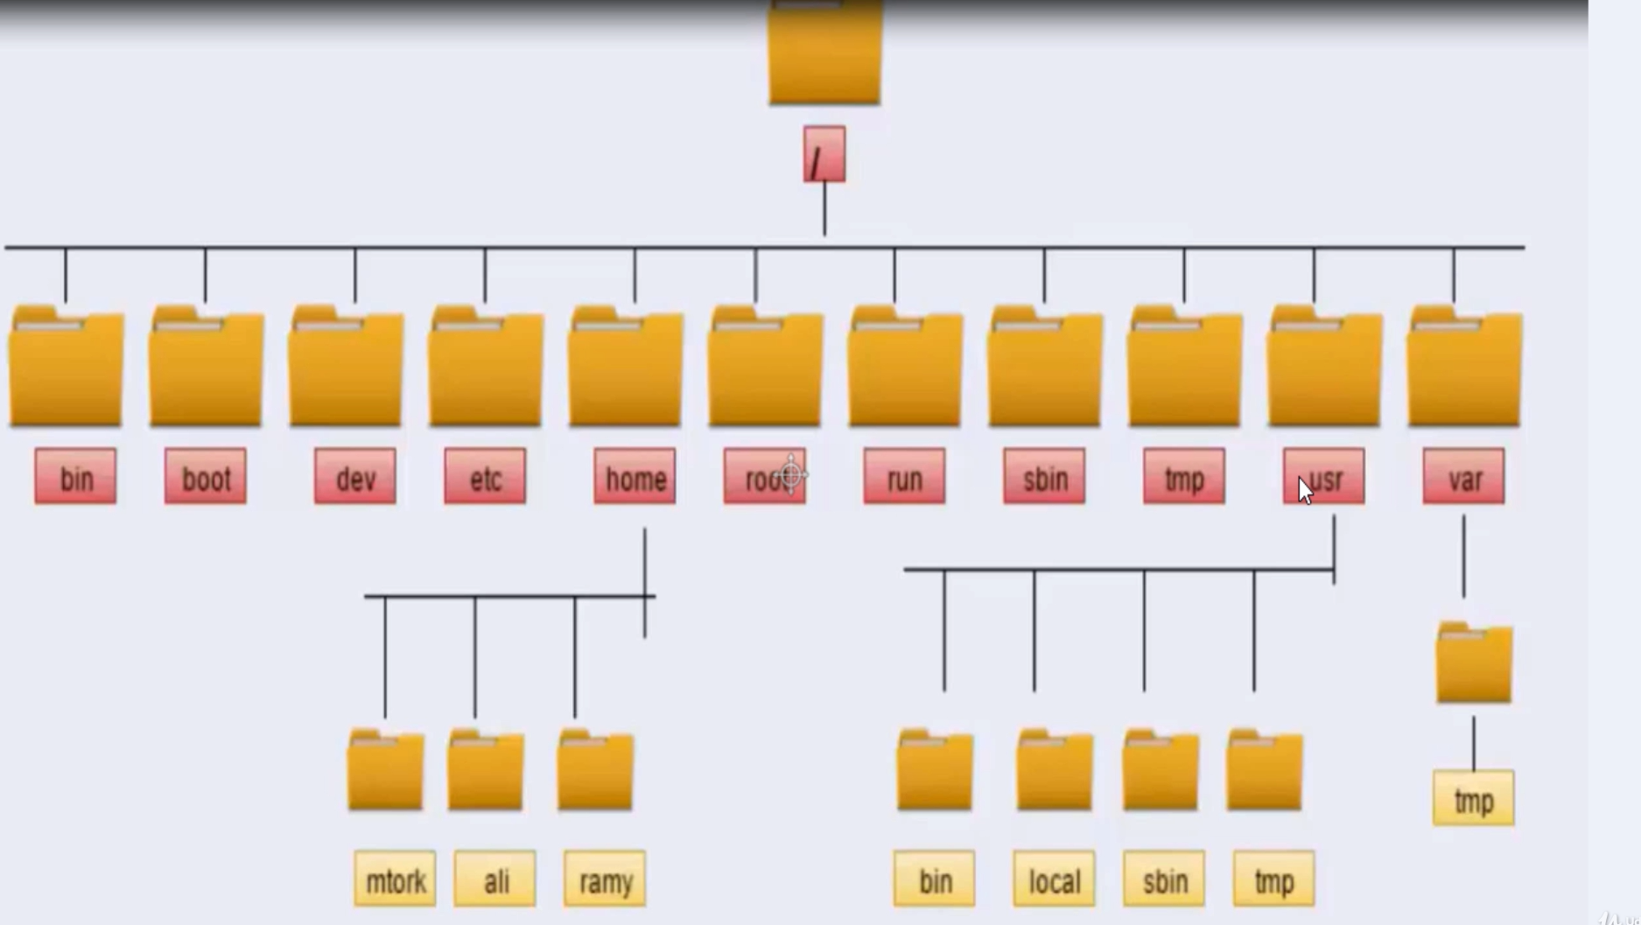
- / -> root directory; root of the file system
- /usr -> Installed applications on the system, shared libraries
  - /usr/bin -> Binary files/Commands used by end users on the linux system (system wide binaries) e.g. cd, mv, etc.
  - /usr/sbin -> Binary files/ Commands only used by the administrator on the system directory
  - /usr/local -> Path Installed applications
  - /usr/tmp
- /etc -> Contains configuration files of the system and applications
- /var -> Files whose size is expected to increase by time such log files; Continuously changing files
  - /var/tmp -> same as /tmp but the files gets deleted after 30 days
- /home -> stores home directory of each user; when a user is created, a directory with the username of the user is created inside this directory
- /root -> home directory of the root user
- /tmp -> temporary files used by the system or applications; these files get deleted after 10 days automatically
- /dev -> has all devices files used by system to access the hardware such as hard disk
- /boot -> contains boot loader files and kernels
- /bin -> contains executable files that are part of the core operating system
- /usr/share/doc -> documentation of applications on the system

File & Directories
- $ touch -> Creates empty files on the path specified
  - $ touch file.txt -> creates a file with name “file.txt”
  - can also be used to create multiple files in a single by providing space separated path to each file name or comma separated list in side curly brackets ({file1.txt,file2.txt })

- $ mkdir -> used to create empty directory
  - $ mkdir test -> creates a directory with name “test”
  - can also be used to create multiple files in a single by providing space separated path to each file name
  - use mkdir -p to create nested directories e.g. mkdir -p /dir1/dir2 will create a dir1 and dir2 inside dir1

Linux Shell Basics
- $ whoami -> logged in user
- $ hostname -> Machine Name
- $ pwd -> current working directory
- $ clear -> clears screen
- $ ls -> shows files and directories
  - $ ls -l -> Long Listing Format (shows more information about the files)
  - $ ls -a -> list all files and directories along with hidden files & directores (starting with .)
- $ cd -> move between directories;
  - $ cd /path/to/directory
  - Can use relative or absolute path to directory to change the current working directory
  - $ cd .. -> moves to parent of current directory
  - $ cd -> moves to home directory of logged in user

File Management (copy, move, delete, rename)
- $ cp source destination -> copies source content to destination
  - can be used to copy multiple files in a single command by specifying a list of source files separated by space followed by a destination
  - $ cp -v -> shows verbose
  - $ cp -r -> to copy directories
- $ mv source destination -> moves source content to destination
  - can be used to move multiple files in a single command by specifying a list of source files separated by space followed by a destination
  - $ mv -v -> shows verbose
  - can also be used to rename a single file
- $ rm file_path -> remove/delete files
  - $ rm -r -> delete directories
- $ rmdir -> delete empty directories

Linux Man Pages
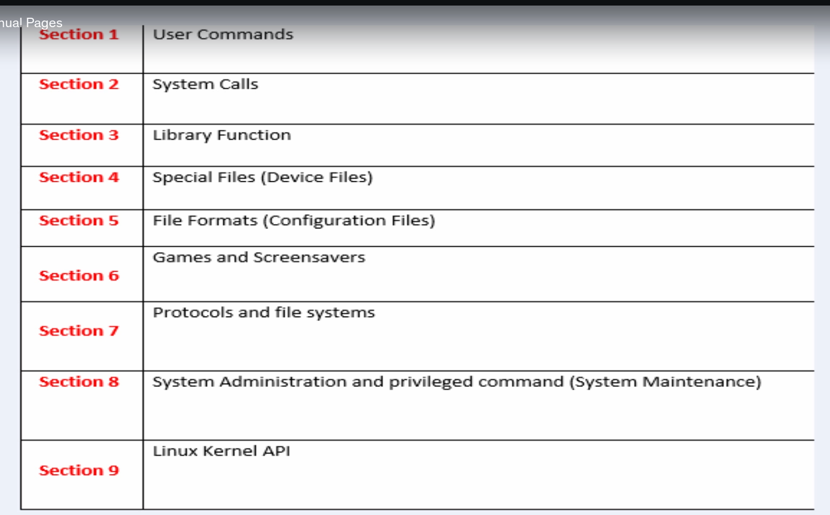
- $ man x resource -> display manual page of the resource belonging to section x
  - man -k str -> search str across all manual pages and list all findings
  - Navigating through man page
    - Pg up -> Above page
    - Pg down -> next page
    - d -> next half page
    - u -> previous half page
    - Use / to search
    - G -> end of page
    - G -> start of page
    - N-> next finding
- $ pinfo -> Similar to man pages but list more information regarding the resource
- $ rpm -qd app -> find documentation of the application of the system
- $ ssh user@machine -> connect to a remote machine at ip of machine with username “user”
  - If you don’t provide user, ssh will use the name of currently logged in user

I/O Redirection
- > : Output redirect operator
  - ls > test.txt
  - Use >> to append the output to existing file
  - Prepend 1 for output and 2 for for error and & for both
- < : Input redirect operator
- Pipe ( | ) -> takes output from previous command and pass to next command
- $ tee -> read from standard input and write to standard output and files

VI Editor
- Command line text editor for Linux system
- Three modes
  - Command Mode
    - Can’t type text
    - Executing commands such as copy, paste, del
    - Press i -> to go to insert mode
    - n yy -> to copy n lines
    - dd -> remove the current line
    - Shift+p -> past copied lines
    - cw -> replace current word
    - cc -> delete content of the line
  - Insert Mode
    - Type text into the file
    - Press Esc to go to command mode
  - Last line mode
    - In command mode, type : to enter in last line mode

Archiving Files in Linux
- $ tar -> archive files in linux
  - $ tar -cvf archive_name list of files -> to archive files
  - $ tar -cvf archive_name name of directory -> archive directories
  - $ tar -zcvf archive_name content -> archive files then compress it
  - $ tar -jcvf archive_name content -> archive files then compress it using bzip2
  - $ tar -tf archive_name -> list all files inside archive
  - $ tar -xvf archive_name -> extract contents of an archive

Compressing Files in Linux
- $ gzip file -> compress files
  - $ gunzip file -> uncompress files
- $ bzip2 file -> compress files
  - $ bunzip2 file -> uncompress files
- $ xzip file -> compress files

Hard & Soft Links
Hard Link
- A pointer to the Inode of the file
- $ ln file_path file_link_to_create -> create a hard link for the at the specified path
- Both link and file have same inode number
- Any modifications to the hard link also updates the file
- Deleting original files will not affect the hard links created
- Hard links can be used as backups

Soft Links
- A pointer to the file
- $ ln -s file_path file_link_to_create -> create a hard link for the at the specified path
- Different Inode numbers for link and file
- Deleting original files will affect the soft links created

Finding Files
- $ locate search_key -> locate any file that contains search key in it name
  - Gives the result from locate database which stores filename and path
  - use -i flag for case-insensitive search e.g. $ locate -i search_key
  - Use -n to limit number of search results e.g. $ locate -n 3 search_key

- $ find path search_options -> search files with specified search option inside the given path
  - -name for case-sensitive search
  - -iname for case-insensitive search
  - -group group_name for files owned by a group
  - -user user_name for files owned by user
  - -uid for files owned by a user
  - -gid for files owned by a group
  - -perm 000 for files with specific permissions
  - -size for files with specific size
  - -mmin -x for files modified within last x minutes
  - -mmin x for files modified x minutes ag
  - -mmin +x for files modifiedbefore last x minutes
  - -type {f|d|l} for searching on basis of file types
  - -links +x for files with hard links (>= x hard links)
  - -type l searches for soft links
  - -type b searches for all block devices

Section 4: Linux System Administration (Chapter 1)

Local Users & Local Groups
- $ id uname -> List group info of a user
- $ ps -> list running process
  - $ ps au -> list user associated with the processes
- /etc/passwd
  - Store information about local users in the system
  - Each line contains the information related to a user
  - Each line consists of seven fields separated by a colon (:) from left to right:
- username
- Initially password information was stored here but now stored in /etc/shadow file
- User id
- User’s primary group ID
- User’s Name
- Path to user’s home directory
- Default Shell for the user (also shows if the user has access to shell or not)
- /etc/group
  - Store information about local groups in the system
  - Each line contains the information related to a user
  - Each line consists of four fields separated by a colon (:) from left to right:
- Group name
- Second field is for password (not used)
- Group id
- Users that are members of the group

- /etc/login.defs
  - Contains default configuration for adding a new user
  - Modify this file to update default configurations of the users created in future
  - Updating this file does not affect the already created users.

- $ useradd uname -> to create a user in the system
- $ passwd -> set a password for a user or update existing one
- $ userdel uname -> remove a user from a system
  - Use -r flag to remove home directory & mail spool
- $ groupadd name -> add a group with the specified name
- $ groupdel name -> delete a group with specified name

Gaining Root Privileges
- su or su - -> login as root
- /etc/sudoers -> sudoers file containing root level permission for not root users
- $ visudo -> Open sudoers file
- Sudo -> can be used to run commands with root privileges if you are allowed to run in /ter/sudoers file or added in the wheel/sudo group

User Management
- $ usermod -> update user details in the system
  - -g for changing primary group for user i.e. -g g_name u_name
  - -aG for append user to another group i.e.
- $ groupmod -> modify an existing group
  - -n for renaming i.e. -n new_name old_name
  - -g for change group id i.e. -g new_id name
- /etc/shadow
  - Stores users password information
  - Have 9 colon separated fields
- Username
- Encrypted Password
- Days since last password change
- Minimum number of days before a passwd must be changed
- Maximum number of days before a passwd must be changed
- Warning in number of Days before a password expires
- Number of days account remains active after password expiration
- Account Expiration Date in number of days
- Reserved for future use
- $ chage -> aging information about a user
  - -l username -> lists the information
  - -d x username -> set number of days after which passwords expires, 0 forces immediate change of password
  - -M x username -> maximum number of days b/w password change
  - -m x username -> minimum number of days b/w password change
  - -E YYYY-MM-DD username -> set expiration date of the user

Configure a System to use Existing Auth Service
- Packages required
  - authconfig-gtk
  - sssd
  - Krb5-workstation
- Use $ authconfig-gtk to launch the LDAP config
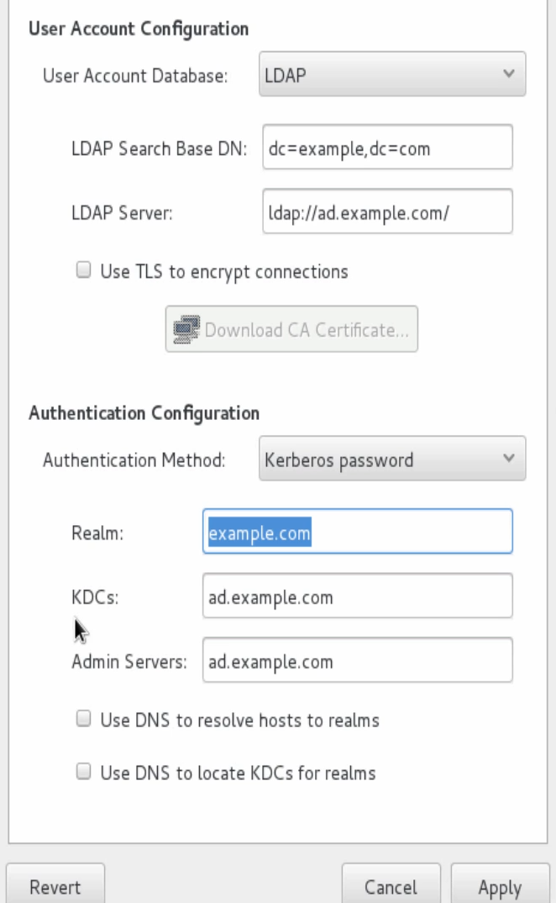
- Once configured, run $ getent passwd uname to verify successful connection
- Us su to login as the LDAP user

Permission Notations
File/Directory permissions are represent as * --- --- --- where * represent the type of file and each group of three - represent permissions for users,group and others. E.g. d rwx r-x r-x represent a directory with read, write, execute permissions for user, & read and execute permissions for group & others
- The type bit value can have one of the three values:
  - - for regular files,
  - d for for directory
  - l for link
- $ chown -> change ownership of files or directories
  - $ chown :newgroup file -> change group of file
- $ chgrp -> change group of file
- $ chmod -> chane file permissions
  - Numeric method -> represent permission in form of 3 octal number for user, group and other respectively
  - Symbolic Method -> use symbol to update permissions
    - u for users, g for group, o for others, a for all
    - r for read, w for write, x for execute,
    - use + to add permissions and - to remove permissions
    - E.g. chmod u+x filename

- Special Permission
  - Setuid
    - If enabled, let other processes/user run a file with permissions of the owner of the file .e.g. passwd
    - chmod u+s filename -> set setuid bit
  - Setgid
    - If enabled on directory, all file inside that directory will have group of the directory as group value.
    - Chmod g+s -> set setgid bit
  - Sticky Bit
    - Prevent deletion of file except from owner/root user
    - Chmod o+t -> set sticky bit
- Umask
  - Used to set default permissions for new created directories
  - Files will have same permissions as directories excluding the execute permissions
  - Stored in .bashrc file located under home directory
  - Default umask is stored in /etc/profile file

Section 5: Linux System Administration (Chapter 2)

Monitoring running processes
- $ ps -> list running processes
  - Shows process id, terminal, elapsed time, and cmd name
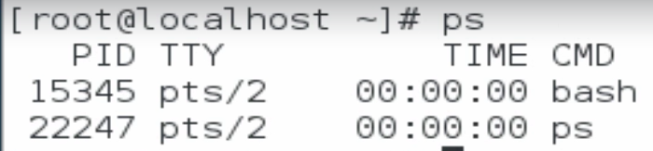
- $ ps aux -> provides more detailed information consisting of 11 columns
- USER -> used related to process
- PID -> Process ID
- %CPU -> CPU utilization of process in percentage
- %MEM -> Memory utilization of process in percentage
- VSZ (Virtual Set Size) -> how much memory a process has available for its execution
- RSS (Resident Set Size) -> Memory currently used by a process
- TTY -> Terminal
- STAT -> Process State. Represented as a sequence of letters
  - First character indicates the state of the process
    - D -> uninterruptible sleep
    - R-> Running
    - S -> Interruptible sleep
    - Z -> Defunct (Zombie)
  - Second character shows additional information
    - W -> no resident page in memory
    - < -> high priority
    - N -> low priority
    - L -> has pages locked in memory
- START -> Start time of the process
- TIME -> How long the process has been running
- COMMAND -> Name of the process

- $ ps -ef -> shows PPID along with other information
- $ ps lax -> shows Flags (F), Nice Value (NI), Priority (PI) along with other information

Running Process in Background
- To run a process in background, append a & at the end of the command
- $ jobs -> list background processes
- $ fg job_number -> bring a background job to foreground
- Press Ctrl+z to send a process to background
- $ bg job_number -> start a background stopped process
- $ kil %job_number -> terminated a background process

Terminate Running Process using kill & pkill
- $ kill -SIGNAL PID or %JOBID -> using to terminate a running process with a specified signal
  - If you don’t pass any signal, the default (SIGTERM) (15) is used
  - SIGKILL (9) -> terminates the process immediately without cleanup
- $ pkill -> kill all the processes realted to a sevice

- $ uptime -> list uptime, load on processor
- /proc/cpuinfo -> contains information related to CPU
- $ top -> real-time information of memory
  - -d n -> refresh after evrey n seconds

Listing unit files Systemctl
- $ systemctl -> manage services running on the system
  - $ systemctl -t help list all the units types
  - $ systemctl status service_name -> status of a service
  - enabled service running on boot
  - $ systemctl –type=<type e.g.service> -> list all units of type service
  - $ systemctl is-active <service> -> check whether a service is active or not
  - $ systemctl is-enabled <service> -> check whether a service is enabled or not
  - $ systemctl list-units --type=service -> list all active services
  - $ systemctl list-units --type=service --all -> list all active and inactive services
  - $ systemctl list-unit-files --type=service -> list all unit files along with their status
  - $ systemctl --failed --type=service -> list all failed services along with their status
  - $ systemctl start service_name -> start a stopped service
  - $ systemctl stop service_name -> stop a running service
  - $ systemctl reload service_name -> reload configurations of the service with restarting it
  - $ systemctl enable service_name -> enable service to start on boot
  - $ systemctl disable service_name -> disable service to start on boot
  - $ systemctl mask service_name -> prevent anyone from starting a service
  - $ systemctl unmask service_name -> unmask a service

System Log Files
- /var/log -> contains system log files
- $ tail -n x filename -> list last x number lines from the file
  - If n is not specified, 10 lines are displayed
- $ head -n x filename -> list first x number lines from the file
  - If n is not specified, 10 lines are displayed
- lastlog file can’t be read by head, tail or less since it is a binary file
  - To view its content, use $ lastlog command
- syslog -> protocol responsible for logging events in log files
- Logfile rotation
  - the logfile is renamed with an appended date of rotation; a new log file is created in which system dumps log; this is done using logrotate utility
  - System keeps the rotated log files for four weeks; after which they are deleted
- syslog is handled by two services
  - rsyslog
    - Responsible for collecting data from different parts of the linux system and routing it to an appropriate log file
    - Data can also be routed to another linux server
    - /etc/rsyslog.conf -> main config file for rsyslog service
    - Message Priorities
      - emerg -> System is unusable
      - alert -> action must be taken immediately
      - crit -> Critical Condition
      - err -> error with the service
      - warning -> warning message
      - notice -> attention required
      - info -> Info message
      - debug -> debug info from the service

    - Different type of facilities in Linux
      - auth or authpriv -> message coming from authorization or security related events
      - kern -> kernel message
      - mail -> message from mail subsystem
      - cron -> Chrome Daemon Messages
      - daemon -> daemon messages
      - news -> network subsystem messages
      - lpr -> printing related messages
      - user -> user programs messages
      - Local0 to local7 -> reserved for local use

    - /etc/rsyslod.d/ -> custom config files can be added inside this directory
      - Format priority(* for all, none to for zero).facility /path/to/store/logs
    - $ logger -> can be used to generate log messages
  - SystemD journal (journald)
    - System service for collecting and storing log data
    - /run/log/jornal/*/system.journal file
    - Clears logs each time you reboot the system
    - $ journalctl ->Displays logfiles in system.journal
      - $ journalctl -n x -> display last x line from journald log file; defaults to 10
      - $ journalctl -p x -> display all messages with priority xfrom journald log file
      - $ journalctl -f -> similar to tail -n; monitor jornald log file and display updates
      - $ journalctl --since x -> display all messages written since time x
      - $ journalctl --since “YYYY-MM-DD HH:MM:SS” --until “YYYY-MM-DD HH:MM:SS”- -> display all messages written between two date
      - $ journalctl _SYSTEMD_UNIT=x -> display all messages of system unit x
    - Saving System Logs on File System
      - Journald has a built in logrotation that keeps data for a month
      - /etc/systemd/journald.conf -> configuration file for systemd journal
      - Create a directory @ /var/log/journal
      - Change the owner group of the directory to root and systemd-journal respectively
      - Change the directory permissions to 2755
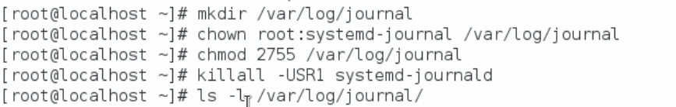
      - Reboot the system

Successful shutdown & reboot a system
- Commands that can be used to reboot the system
  - $ reboot
  - $ shutdown -r
  - $ Init 6
  - $ telinit
  - $ systemctl reboot
- Command to Shutdown the system
  - $ shutdown
    - Broadcasts a message to all users that the system is going to shutdown
    - $ shutdown -h HH:MM -> schedule system poweroff
  - $ halt
  - $ systemctl halt
  - $ init 0
  - $ telinit 0
  - $ poweroff
  - $ systemctl poweroff

Boot into Different Targets
- /usr/lib/systemd/system
- Target -> different states that your system can boot into
- Systemd -> system management daemon
  - Older version use init
- $ systemctl get-default -> get default target
- $ systemctl list-dependencies target_name -> list of services dependent on the target
- $ systemctl isolate target_name -> switch to a different target
- $ systemctl set-default target_name -> set default target

Adjust Process Priority with renice
- $ nice -n x command -> run a process with a specified nice value x
- $ renice -n x PID -> change the nice value of a running process with PID

Section 6: Linux System Administration (Chapter 3)

Linux File System
- $ df -> display partitions and their usage
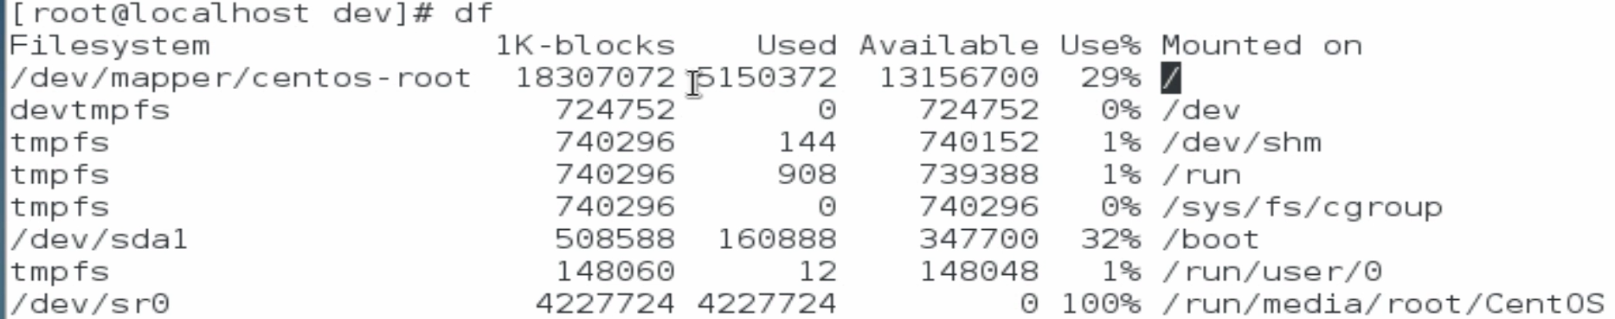
  - $ df -h -> display partitions and their usage in readable format

- tmpfs -> temporary file system; uses local memory for file system reads and writes

- $ du -> works similarly like df but run on directories
  - $du -ah -> for extra details and human readable format

Mounting File System
- $ blkid -> list the UUID of the file systems on the system
- $ mount /dev/dev_id /mounting/point ->mount a partition on the specided path
  - $ mount UUID=”UUID of device” /mounting/point ->mount a partition on the specided path
  - $mount -a -> mount all the file systems listed in /etc/fstab/ file
- $ umount /mounting/point -> unmount a device
  - $ lsof /mounting/point -> list processes using the device
- $ fdisk -l -> list all the partitions along with their details
- $ parted -> utility for managing disk and partitions in file system
- $ fdisk /dev/<dev> -> create partition inside a disk
- $ mkfs -t <target_file_system> /dev/<dev_id> -> format a a partition with a specific file system
- $ fsck.<file system> /dev/<dev_id> -> check and repair one or more linux file systems
- $ dumpe2fs /dev/<dev_id> -> display information about a partition
- $ xfs_info /dev/<dev_id> -> list information about xfs file system
- $ xfs_repair /dev/<dev_id> -> heck and repair xfs file system

CIFS & NFS
- Both Network File System (NFS) & Common Internet File System (CIFS) are file sharing protocols that allows you to configure a server to be a file sharing system across the network
- NFS is used to share file system among the Linux Machines.
- CIFS is used when you want to share a file system among a mix of Linux and Windows Machine
- NFS
  - Add hostname of your NFS Server in /etc/hosts
  - $ mount -t nfs hostname:/path/to/shared /mounting/point -> Mount an NFS Share
  - To make the mounting boot persistent, add an entry with /etc/fstab file
    - Hostsname:/path/to/shared /mount/pint nfs4 default 0 0

- CIFS
  - Add hostname of your NFS Server in /etc/hosts
  - To make the mounting boot persistent, add an entry with /etc/fstab file
    - //Hostsname/shared /mount/pint cifs rw,user=uname,password=passwd 0 0

Logical Volumes
- Use t in $ fdisk /dev/<dev_id> to change the disk to logical volume.
  - Type L to list all the possible values

- $ pvcreate /dev/<dev_id> -> to create a physical volume
- $ pvdisplay -> list physical volumes
- $ vgcreate name /path/to/partition -> create a volume group
- $ vgdisplay -> list all the Volume Groups
- $ lvcreate -n name -L size <volumeGroupName> -> Create a logical volume with specified name and size
- $ lvdisplay -> list logical volumes
- $ pvmove /dev/<dev_id> /dev/<dev_id> -> Move data from one physical volume to other
- $ vgreduce vg_name /dev/<dev_id> -> remove a volume from a volume group
- $ lvextend -L 7G /dev/vg_name/data -> extend the logical volume size
- $ xfs_growfs /mt/pt -> reflect changed size of lv for xfs FS
- $ resize / -> reflect changed size of lv forEXT4 FS

Access Control List (ACL)
- Gives you ability to add more flexible permission mechanism for your files system
- Enabled by default in ext4 & XFS file systems
- $ getfacl /path -> ACL of the Specified directory/file
- $ setfacl -m u:uname:permission /path -> to provide user permissions to a file/directory by updating ACL
- $ setfacl -m d:u:uname:permission /path -> to provide user permissions to a directory by updating ACL; also enabling files & directories within to inherit the Updated ACL; only for newly created directories
- $ setfacl -R -m u:uname:permission /path -> updated the ACL of directory recursively
- $ setfacl -m g:uname:permission /path -> update ACL of the groups
- $ getfacl /path | setfacl --set-file=- filename -> copy ACL of one file to another

Network Time Protocol (NTP)
- NTP synchronizes the time on your system with a centralized NTP server
- $ timedatectl -> list current time configuration
- $ timedatectl list-timezones -> list all the time zones
- $ timedatectl set-timezones <timezone> -> change the timezone of the of your system
- /etc/ntpd.conf -> config file for ntp
- $ ntpq -p -> list detailed time synch information
- $ ntpstat -> list basic time synch information
- $ ntpupdate host -> Update the NTP server
- $ chrony
  - synchronize the system clock with NTP servers, reference clocks: (e.g. receiver), and manual input using wristwatch and keyboard. It can also operate as an NTPv4 (RFC 5905) server and peer to provide a time service to other computers in the network
  - /etc/chrony.conf -> configuration file for chrony
    - Update this file with local NTP servers like allow X.X.X.X
  - $ chronyc source -v -> list NTP servers
  - $ chronyc check -> Check NTP Configuration

Network Configuration
- $ ip addr -> list all the network devices to system
- $ ip addr show <nic> -> show information about the specified NIC
- $ ip -s link show <nic> -> show information about the performance of specified NIC
- $ ip route -> list all the possible routes
- $ ping host -> check connectivity with a host
  - $ ping -cx host -> ping a host with x number of packets
- $ tracepath host -> trace path of the packet as it travels from source to destination
- $ traceroute -T host -> trace path of the packet as it travels from source to destination using TCP
- /etc/services -> All well known services for standard ports are listed in this file
- $ ss -ta -> list all the connection on a system; LISTENING
- $ ss -ta -> list all the connection on a system; LISTENING, also lists port number
- $ netstat -> similar to ss

- $ nmcli -> cli utility to configure the network connection on your system
  - $ nmcli con show -> list all available connections on the system
  - $ nmcli con show --active -> list all active connections on the system
  - $ nmcli con show “con_name” -> list all information about the specified connection
  - $ nmcli dev status -> list all network devices along with their status
  - $ nmcli dev show “dev_name” -> list all information about the specified network device
  - $ nmcli con add con-name <name of connection> type ethernet ifname <device name> -> add a new connection
  - $ nmcli con mod con-name <name of connection> <options> -> modify an existing connection
  - $ nmcli con up -> start an existing connection

- Editing Network Config Files
  - /etc/sysconfig/network-scripts -> config files for each NIC
  - You can edit hese config files to modify setting for the specific NIC
  - $ nmcli con reload -> to reload connection confg
  - $ nmcli con del “con_name”-> to delete a connection

Configure Hostname and Name Resolution
- $ hostnamectl -> utility to manage hostname of the system
  - $ hostnamectl set-hostname <hostname> -> change hostname of system
- /etc/hosts -> contains host to IP mapping for different host; system looks for host IP in this file first; If not found it goes to DNS server

Install & Update Software with yum
- $ yum -> package manager in Linux
  - $ yum list -> list all the installed packages
  - $ yum list “str”-> list all the installed packages matching a string sequence or regex
  - $ yum search “str”-> search all the available packages matching a string sequence or regex
  - $ yum info “pkg_name”-> list information about a package
  - $ yum provides /path/to/file -> list packages that configures this specified file
  - $ yum install “pkg_name” -> install a specific package
  - $ yum update -> update installed system packages
  - $ yum remove “pkg_name” -> remove a specific package
  - $ yum grouplist -> list all yum groups
  - $ yum group info “grp_info” -> list all info about a yum group
  - $ yum group install “grp_info” -> install all packages inside a yum group
  - $ yum history -> history of actions on packages
- /var/log/yum.log -> log file of the yum package manager
- rpm package files -> package manager
  - $ rpm -q “pkg_name” -> display info the package specified
  - $ rpm -q -f /path/to/file -> list packages that configures6 this specified file
  - $ rpm -q -l “pkg_name” -> list all files installed by package
  - $ rpm -q -d “pkg_name” -> path of documentation file for the server
  - $ rpm -ivh “repo_link” -> install a repo from the provided link

Task Scheduler
Linux enables you to run specific bash scripts/commands at specific time by use to at and cron
- $ at <time string to execute commands> -> provide commands and press Ctrl+D to save the scheduled job
  - $ atq -> list all at jobs
  - $ atrm job_num -> remove a job
  - /etc/at.deny -> any username inside at.deny won’t be allowed to use at command
  - /etc/at.allow -> any username inside at.deny will be allowed to use at command
  - Both of the above two files are mutually exclusive i,e, only one exist at a time
- Cron job -> schedule task to run periodically
  - $ crontab -> command used to manage cron jobs
  - /etc/crontab -> stores all the cron jobs
  - $ crontab -e -> open the crontab files
    - A cron jon entry 7 fields separated by space
- Minutes (0-59)
- Hour (0-23)
- Day (1-31)
- Month (1-12)
- Day of Week (0-6) Sunday = 0
- User
- Command
  - $ crontab -l -> list all cron jobs
  - $ crontab -l -u uname-> list all cron jobs of a user
  - $ crontab -r -u uname->remove all cron jobs of a user
  - /etc/cron.deny -> any username inside cron.deny won’t be allowed to use at command
  - /etc/cron.allow -> any username inside cron.allow won’t be allowed to use at command
  - Both of the above two files are mutually exclusive i,e, only one exist at a time
  - /etc/cron.d -> directory for custom cron jobs; any files inside this directory will be read by the cron and run
  - $ cron misses the schedule if the system is powered off this limitation is overcome by anacron
- $anacron -> doesn’t assume that your system is up and running 24/7; it executes job after the downtime
  - Uses timestamps associated with files to see when it was last run and comparing it with its cron entry, it runs the command if necessary
  - $anacron -n -> run all anacron jobs
  - /var/spool/anacron -> anacron stores timestamp in this file to compare for next execution
  - An anacron entry consists of four columns
    - Period In days
    - Delay In Minutes (time after which the command runs, after starting anacron)
    - job-identifier
    - command

Section 7: Linux System Administration (Chapter 4)

Key based SSH Authentication
- $ ssh-keygen -> to generate pub/priv key pair
- $ ssh-copy-id root@remoteServer -> copy the public key to remote server
- $ ssh root@remoteServer -> connect to remote server

Disallow Root User Remote Login
- /etc/ssh/sshd_config -> Main Configuration File for SSH
- Update this file with PermitRootLogin parameter set to no to disable root user remote login
- Update this file with PermitRootLogin parameter set to without-password to allow only ssh key
- Update this file with PasswordAuthentication parameter set to no to allow only ssh key for non-root users

Copying Files Securely between Systems
- $ scp /path/to/source /user@IP:/path/to/destination -> copy local files to a remote server
  - $ scp -r /path/to/source /user@IP:/path/to/destination -> copy local directories to a remote server
  - scp can also copy from remote source to local destination or remote-to-remote

- $ sftp
  - $ sftp user@host -> establishes an sftp connection to remote machine
  - Prepend L to commands to run on local machine
  - Commands without L will run on the remote server
  - $ put filepath -> upload files to remote server
  - $ get filepath -> download files from remote server

Synchronizing Files & Folders Securely between Systems
- $ rsync -> used to copy files & directories securely between systems
  - similar to scp but copies the changes only
  - $ rsync -av /source /dest -> sync two directories
  - $ rsync -av /source/ /dest/ -> sync the contents of the directories without recreating them

Firewalld service
- $ firewalld -> firewalld service
- $ firewall-config -> firewall-config (GUI interface for managing firewall)
- $ firewall-cmd --get-zones -> list available zones inside the firewall
- Zones
  - gives your more flexibility by adding rules to multiple zones
  - Each zone is takes care of your security in a specific location or situation
- $ firewall-cmd --get-default-zones -> list default zone of firewall
- $ firewall-cmd --list-all -> list firewall rules of the default zone
- $ firewall-cmd --list-all --zone=home -> list firewall rules of the default zone
- $ firewall-cmd --zone=home --parameter=value -> update the parameters of the specified firewall zone (these changes are not persistent)
- $ firewall-cmd --zone=home --parameter=value --permanent -> update the parameters of the specified firewall zone (these changes are persistent)
- $ firewall-cmd --reload -> reload firewall configurations
- $ firewall-cmd --panic-on -> block all incoming traffic
- $ firewall-cmd --panic-off -> return to normal state of the firewall
- $ firewall-cmd --add-service=<serviceName> -> add service to the firewall
  - Use --permanent to make it boot persisten
- $ elinks protocol://host -> test a service

Introduction to SELinux (Security Enhanced Linux)
- Add/.s another layer of security to the Linux
- Limits access to files to prevent malicious attacks
- Can prevent users from executing shell scripts inside their home directories
- Uses booleans to make its policy more flexible
- /etc/sysconfig/selinux -> config file for SELinux
- SELinux operates in three modes
  - Enforcing -> policies enforced
  - Permissive -> prints warnig instead of enforcing
  - Disabled -> No SELinux policy
- $ sestatus -> get current mode of SELinux
- $ getenforce -> get current mode of SELinux
- $ setenforce mode -> set current mode of SELinux
- SELinux has three policies
  - Targeted -> targeted processes are protected
  - Minimum -> Only selected processes are protected
  - mls -> Multi-level security protection

- Labels
  - Set in context
  - Every process has an associated context type
- $ semanage fcontext -l -> list all possible contexts
  - Any file created within directory will inherit the context from its parent directory
- $ restoercon file -> resture default context of file
- $ semanage context -a -t httpd_system_content_t ‘/mysites(/.*)?’ -> change the context of all files with in directory
- $ restoercon -RV /mysites -> apply the updated contex of the files and directories
- $ semanage context -d ‘/mysites(/.*)?’ -> delete the context type
- $ getsebool -a -> get SELinux boolean and their current value
- $ semanage bool -l ->get SELinux boolean and their current value with details
- $ setsebool <boolean_feature> value(on/off) -> enable or disable an SELinux Boolean feature
- $ setsebool <boolean_feature> value(on/off) -P -> enable or disable an SELinux Boolean feature with persistance
- /var/log/audit/audit.log -> SE Linux Log Files
- $ sealert /var/log/audit/audit.log -> View SE linux logs in a more readable format

Section 8: Linux System Administration (Chapter 5)

Configuring Network Teaming
- Network teaming provide the following benefits:
  - Network teaming ensures a high level of availability.
  - Multiple connections provide the best performance.
  - In the event of system hardware breakdown, it assures network continuity.
  - It allows traffic to be rerouted across networks

- Package teamd is used ot configure network teams
- $ nmcli con add type team con-name team0 ifname team0 config ‘{“runner”: {“name”: “activebackup”}}’ -> create a new masterteam connection
- $ nmcli con add type team-slave con-name team0-slave0 ifname eth0 master team0 -> create a slave team connection
- $ teamdctl team0 state -> current state of connection team
- $ pin6 -I interface_name IPv6 -> ping an IPv6

Firewall (Rich Rules)
- Helps create complex firewall rules in a more easy to understand manner
- $ firewall-cmd --add-rich-rule ‘rule family-ipv4 source address=x.x.x.x accept’
  - Create a rich rule
  - You can add --permanent to make the rule persistent
- More info in -> $ man 5 firewalld.richlanguage

Configuring Network Address Translation (NAT)
Can be done by Masquerading or Port Forwarding
Masquerading
- Used to forward traffic from internal network to public network through a configured server that acts like a router
- $ firewall-cmd --permanent --zone=public --add-masquerade -> enable masquerading
- $ firewall-cmd --permanent --zone=public --remove-masquerade -> disable masquerading
Port Forwarding
- Forwards all traffic, destined to a specific port, to a different port on the local machine/external machine
- For external Linux Machine, Masquerading needs to enabled before using the port forwarding
- Command to add port forwarding rule

Configuring System as an iSCSI Target
- iSCSI ->
  - Internet Small Computer Systems Interface
  - Network protocol that allows you put hard disks in a sandbox.
  - Consists of two Components i.e. Target & Client
- Target
  - $ targetcli -> CLI interface to configure iSCSI target
    - > backstores/block create block1 /dev/sdc -> Create a block storage object
    - > iscsi/ create iqn.2017-03.com.ine:t2 -> create qualified domain name for the target
    - > cd iscsi/iqn.2017-03.com.ine:t2/tpg1 -> open the block storage object
    - > luns/ create /backstores/block/block1 -> Create Logical Unit Nmbers
    - > acls/ create iqn.2017-03.com.ine:client -> Create ACL for client
    - > cd acls/iqn.2017-03.com.ine:client/
    - > set auth userid=lunuser
    - > set auth password=12345
    - Open ports in the firewall for your block storage
    - Start the target service

- Client
  - $ iscsi-initiator-utils -> package to configure iSCSI client on system
  - /etc/iscsi/ -> Configuration directory containing config files for iscsi
    - Update iscsid.conf with username and password of the target
    - Add initiatorname.conf containing fqdn of the block storage device
    - $ systemctl start iscsi -> start the iscsi service
    - $ isciadm --mode discovery --type sendtargets --portal X.X.X.X
      - Return fqdn of the iSCSI target
    - $ isciadm --mode node --targetname fqdn_of_iscsitarget --portal X.X.X.X --login
      - Connect to the iSCSI target

Kernel Runtime Parameters
- /proc/sys/kernel -> contains all the kernel related information files
- $ sysctl -a -> list all system parameters
- $ sysctl -a | grep kernel -> list all kernel parameters
- $ sysctl -w kernel.<parameter>=value -> change the value of the kernel parameter
- $ echo “value” > /proc/sys/kernel/<parameter> -> change the value of the kernel parameter
- This method is not boot-persistent. For boot-persistent kernel changes, edit the /etc/sysctl.conf and add a line in the format kernel.<parameter>=value, and save it.

System Reports
- $ iostat -> displays average CPU and the devices on the system
- $ pidstat -> displays information about the current running processes
- /etc/sysconfig/sysstat -> configuration file for sysstat
- /var/log/sa -> directory for log files
- $ sadf -d /va/log/sa/<filename> -- -u -r -dp -n DEV -> display sysstat files in readable format

Section 9: Linux System Administration (Advanced Topics)

Installing packages with yum and rpm
- yum
  - Package manager in the RHEL systems
  - Installs dependencies along with the package
  - $ yum install <package> -> install a package
  - $ yum group install <group_name> -> install a package group
  - To download rpm package files, we need yumdownloader which can be installed by $ yum install yum-utils -y
  - $ yumdownloader <package> -> download rpm package
- rpm
  - Legacy Package manager in the RHEL systems
  - Doesn’t Installs dependencies along with the package

Enable Custom Ports for Services
- $ yum install setroubleshoot-server selinux-policy-devel -> required packages
- $ semanage port -l | grep -w <service_name> -> list all the ports used by the service
- $ sepolicy -network -p <port> -> Check if a port is used or not
- $ semanage port -a -t <service> -p tcp <port> -> add custom port for the service
- $ semanage port -d -t <service> -p tcp <port> -> delete custom port for the service

Enable/Disable System Startup Services
Refer to this heading

